1-Page Summary Report

Problem Statement
Estimate the linear relationship between employment-campaign advertising/outreach spend and the number of successful job placements, and (as secondary practice) the link between training weeks and employment rate. The educational goal is to implement simple linear regression both from scratch via gradient descent on squared-error loss and with scikit-learn / closed-form OLS, then explore sensitivity to learning rate, noise and sample size — framed for workforce development, HR and labor-policy audiences.

Solution Strategy
1. Explore the campaign spend–placements scatter. 2. Define SSE loss and derive analytic gradients for slope and intercept. 3. Implement iterative gradient descent with a centering trick for numerical stability. 4. Verify against the normal equations and sklearn LinearRegression. 5. Diagnose residuals and run Monte-Carlo simulations. 6. Estimate a training-intensity model (employment rate on training weeks) as additional practice. Audience-aware language is prepared for labor economists, HR/workforce executives, policy analysts and non-specialists.

Solution
Key numerical results (campaign spend → placements): slope (marginal placements) ≈ 1.11 placements per $1k campaign spend, intercept ≈ 16.7, R² ≈ 0.59. From-scratch centered GD, closed-form OLS and sklearn agree closely. Residual plots show no strong systematic pattern.
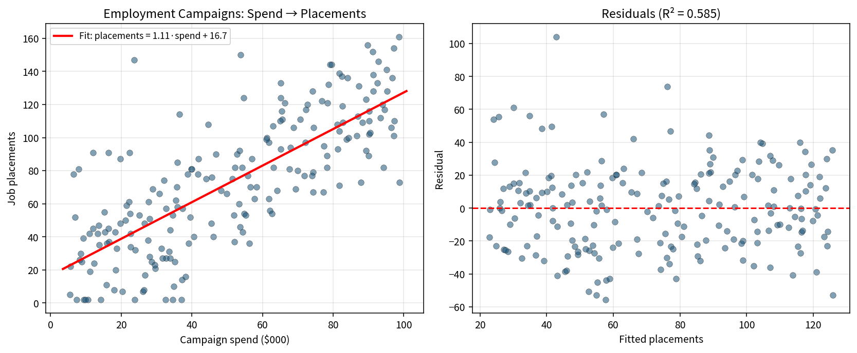
Training practice: ≈ 4.4 percentage points higher employment rate per extra week of training.
Audience translations: Executive — “Each extra $1 000 of campaign spend is associated with roughly 1.1 additional job placements; the model explains about 59 % of placement variation.” Training/policy — “Each extra week of training is linked to about 4.4 pp higher employment rate.” Non-specialist — a rising line through a cloud of points showing that campaigns that spend more tend to place more people.

Key Takeaways
• The line of best fit minimises average squared loss; lower loss is better on the same data.
• Gradient descent moves parameters opposite the loss gradient; learning rate controls step size.
• Centering predictors and response stabilises GD when workforce variables have different scales.
• sklearn, closed-form and a correctly implemented GD recover the same simple-OLS coefficients.
• Always adapt charts and language to the audience’s data literacy and subject knowledge (labor economists vs HR executives vs non-specialists).
• R² ≈ 0.59 indicates campaign spend is a useful but incomplete predictor of placements; local labor demand and candidate quality also matter.

